3M ELECTRICAL MARKETS PRODUCT CATALOG
Training Guide
Updated 5-2019

Navigating the Catalog
The 3M Product Catalog allows you to find and export product details. You can navigate the catalog to find the products you’re interested in by using the search bar at the top, with the filters to the left of the product listings, or by pasting in a list of UPCs for which you’re interested in getting more information.

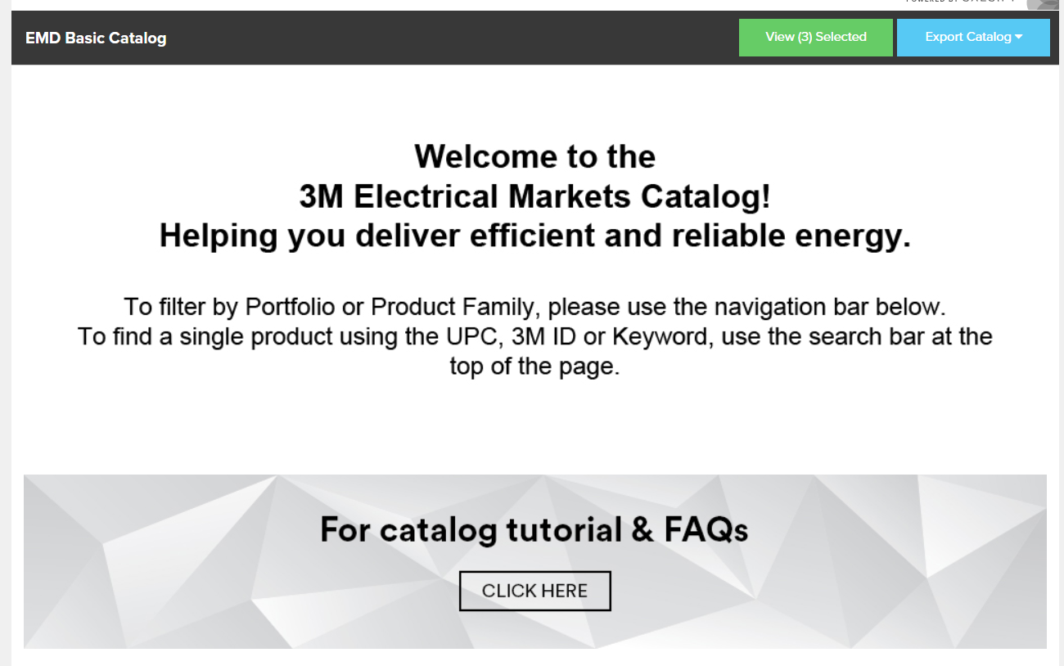

Using the Search Bar

- Type the UPC, 3M ID or keyword in the search bar.
- Press Enter or the search button to get search results. UPC and 3M ID will take you directly to the product detail page. A keyword search will filter the page to only show products containing that keyword. To view the product detail page for a specific product in the search results, click the product image.

Using Filters
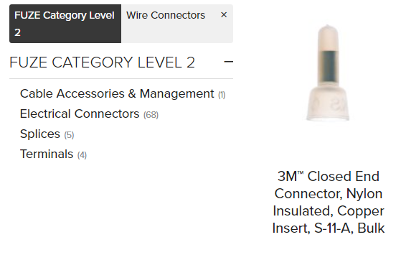

- Click the filter item you would like to use to narrow your search. The number of products in each filter section is shown to the right of its name.
- Filters remain selected until you clear them and can be combined to further narrow results.
- Click the x next to the filter name to remove the filter and return to the unfiltered list.

Using Bulk Filtering
If you have a list of products that you want to get information for, bulk filtering allows you to paste in a set of 14-digit UPCs and narrows the catalog results to the UPCs you choose.

- Click the blue + button next to the search bar at the top of the page.
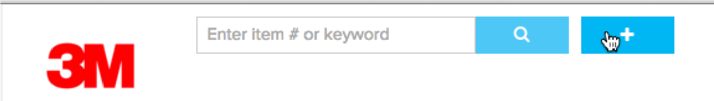

- Paste a list of 14-digit UPCs in the search box, and press Filter
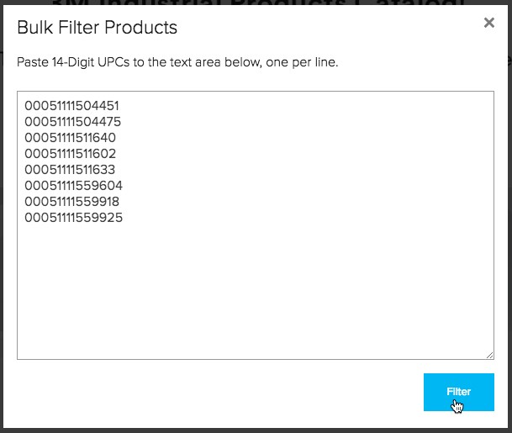

- The catalog will be filtered to the products you selected. You can click product images to view details about individual products, or export this set of products. You can add or remove products from your bulk filtered list individually – see section on Selecting Individual Products for Export.

Product Detail Page
You can view the details of a product by clicking it.
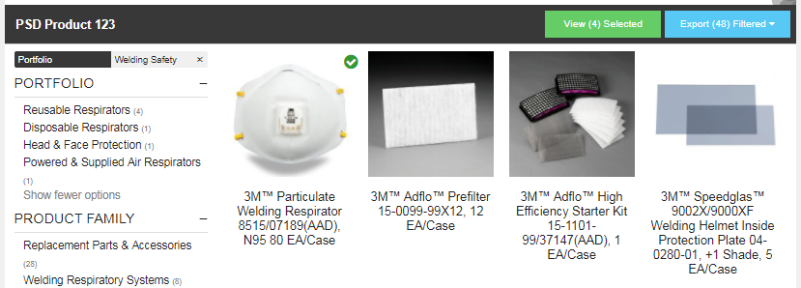

You’ll see the product details and images associated with the product. Next, learn how to create and export a specific list of products.

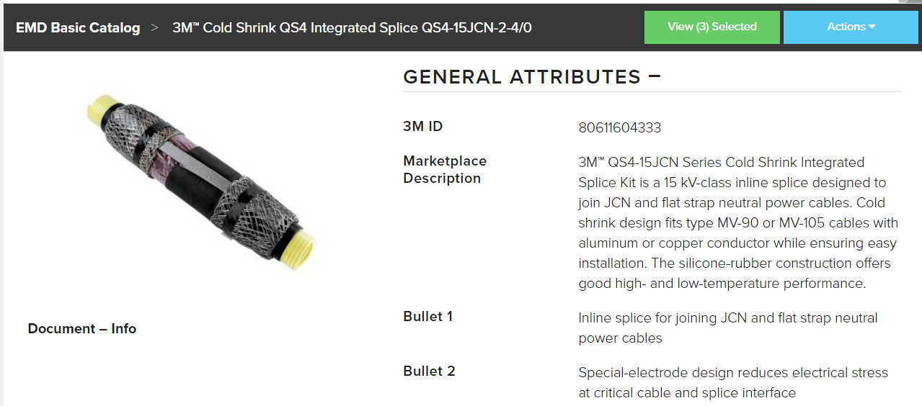

Selecting Individual Products for Export
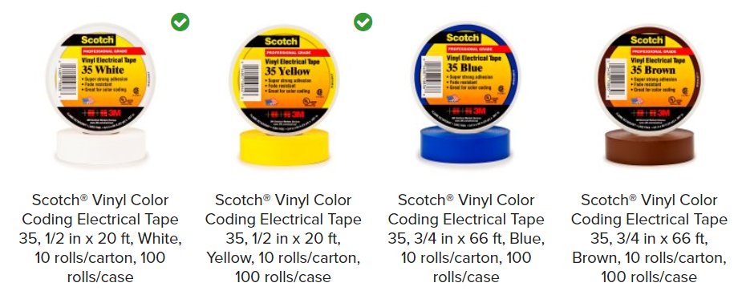
- Select individual products by hovering over the product image until the Select bar at the top appears. Click to add the product to your list.
- Selected products will display a green check mark in the upper right corner.
- To see your full list of selected products, click the View Selected button.

Exporting Product Information for Selected Products

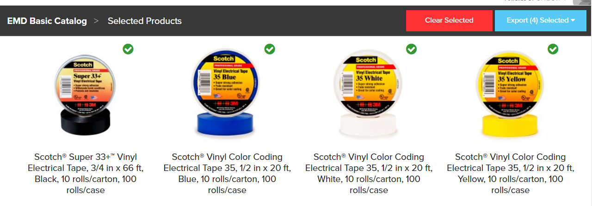

You can make adjustments by unselecting individual products from the View Selected screen, or if you want to empty your list and start over, choose Clear Selected.
When you’re ready to export bulk filtered or individually-selected products for export:
- Click Export Filtered.
- Choose Product Spreadsheet from the dropdown menu receive an Excel spreadsheet containing all product information
- Choose Product Assets from the dropdown menu to receive only marketing assets (images, pdfs-informational fliers, tech bulletins, etc.)

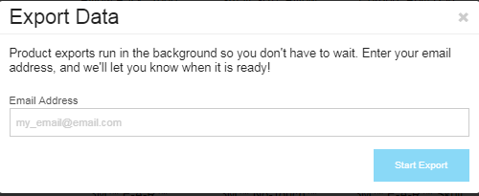

- Enter your email address to receive an email with a link to the catalog export Excel document.
- Click Start Export.

You will receive an email similar to the one below. Click the indicated link to start the Excel file download. **Please check your spam folder if you do not receive the email within ten minutes**

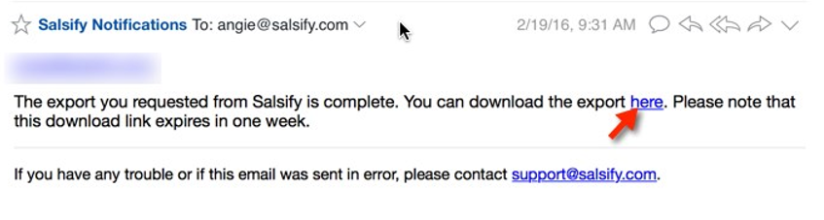

Exporting Product Information for the Full Catalog
You can export the full catalog by clearing all filters and selections.

- Click Export Catalog and choose Product Spreadsheet from the dropdown menu.
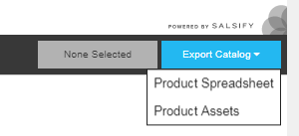

- Enter your email address in the pop-up box and click Start Export. A link to the catalog will be delivered to you when it’s ready. Please note that due to its size, this may take up to an hour.

Using the Product Spreadsheet Export

- Information for the products you selected is available under Product Data.

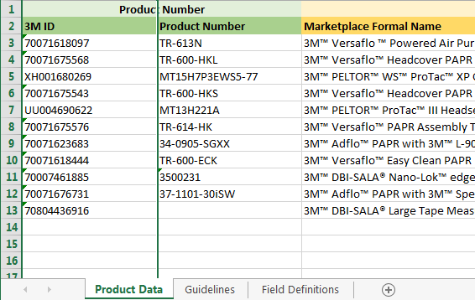

Using the Product Assets Export
- Information for the products you selected will be in a zip file.
- Open the document at the end called Manifest to see an explanation of what is available.

